Managed Workspace and Room Hire
Key issues for sustainability

Table Of Contents

Introduction 2
Managed Workspace 3
Customers: 4
Legal Issues: 5
Setting the Rent: 5
Customers: 8
Understanding costs 14
Marketing 16
Appendix A) Room Hire Information 18
Appendix B) Terms and Conditions 19
Appendix C) Example of a Booking form 22

Introduction

This guide is aimed at any community organisation which either lets out space in a community building, or is considering doing so. Room hire and managed workspace help community organisations to achieve their social purpose and are usually a key element of their income. This guidance focuses on the key issues relating to operating managed workspace and room hire, which have been raised by projects on the Community Ownership and Management of Assets programme (the Community Assets programme).
The Community Assets programme was funded by the Department for Communities and Local Government in 2015/16. It supported 51 partnerships between community organisations and local public organisations with progressing ambitious multiple community asset ownership and management projects and ground-breaking single asset transfer projects to produce novel and replicable learning for other places.
Most community buildings will not be starting from scratch – they will already have a programme of room hire and may have some tenants. This guidance focuses on increasing the viability of a community building by increasing income from lettings.

This guidance assumes that the Board (management committee) has:

- Agreed its purpose (social mission).
- Consulted the local community and set priorities accordingly.
- Considered whether the organisation meets the needs of all sections of the community.
- Has developed or is in the process of developing a business plan.
- Explored its VAT position if annual turnover is above the threshold (2015-16 - £82,000).

Guidance on these issues can be found in To Have and To Hold which can be downloaded from the My Community website www.mycommunity.org.uk

If you are embarking on a refurbishment project, you will have opportunities to develop the space to meet the needs of potential customers and to incorporate design features to reduce expenditure. This guidance does not cover building projects, and the implications of any commercial property arrangements that community groups may choose to enter into are outside of the scope of this guidance. If you are in such a situation we advise that you give a detailed brief to your architect. Further details can be found in To Have and To Hold.
“Key learning point” boxes are provided in this guide to summarise the most important lessons and reflections to consider when thinking about managing workspaces or hiring rooms.
Key learning point: A study visit can be an effective way to research your plans. Hearing the experiences of people involved in the same type of work can give you valuable ideas and prevent you from making costly mistakes.

Managed Workspace

Customers:
It is important to understand your customers. If you already let out managed workspace, keep in regular contact with them and keep an eye on what your competitors are doing. Some questions to consider when thinking about existing customers in relation to your building include:
What do they like? example 2

What are their other options?
What do they dislike?

Existing
Customers

Do they want to move out?

How are they funded?

Are their needs changing?

If you are developing new managed workspace, research the market in your area. Find out if there is a shortage of a particular type of managed workspace. Are there lots of offices or workshop units advertised for rent locally? Are some sizes of managed workspace fully let? The economic development section of your local authority may be able to advise you further. Do you know local businesses or organisations which would be interested in renting space from you? Indicate the kind of rent you plan to charge when you research your market. If this deters most of your potential customers then rethink your business plan.
Key learning point: A gap in provision does not necessarily mean there is a market. For example, your research may show that there are very few small offices in your area. But does that mean there is an unmet need? There may be no small offices because there is no demand – small businesses may opt to save on office costs by working from home.

Think about how the building works from the viewpoint of the tenant. Making small changes can transform the impression that tenants and visitors have of the building. Some key areas to consider are set out in the diagram below:
How do tenants access the building? Most tenants of managed workspace will require access 24/7. Is it easy to get access out of office hours? Does it feel secure?

How do visitors access the building and find your tenants? If there is no staffed reception, is there clear signage and entry phones which are fit for purpose?

Do tenants and visitors have to walk past smokers at the entrance or volunteers drinking coffee in the reception area?

Legal Issues:
Use Options to consider for Renting out Extra Space in Locality’s Legal Toolkit to decide on whether to use a tenancy, licence or tenancy at will. We recommend that you take legal advice.

- Do not rely on the fact that a document calls itself a licence; if the terms of the licence create a lease, then you have given your tenants a lease and may have breached your own lease.
- If you hold your building on a lease, you may need landlord’s permission to sub-let.

Setting the Rent:
Make sure that you understand the costs you will incur in providing managed workspace – this includes the staff needed to provide any services you include in the rental charge. See section ‘Understanding Costs’ for more information on this and an example expenditure budget. You should also include your marketing costs – see the section ‘Marketing’ for more details about the importance and effectiveness of marketing your workspace and rooms.

Does your rental charge include the following items?

Car Parking
Reception
services
Business
Rates
Utilities
and Water Rates

IT, broadband or phone
Office Cleaning and Caretaking
Office
equipment or services

If you do offer the above items, have you considered them in detail for example:

- Providing a broadband service may be attractive to potential tenants, but it can also be one of the main things that tenants complain about. Do you have the staff and/or volunteers to deal with problems?
- Will offering car parking impact on the other services you provide – will it cause problems for people arriving for courses, meetings and events?
- If you include reception, then any reduction to this service will require you to renegotiate the rent. Many community buildings choose not to operate a traditional reception as it may not be the most effective use of valuable staff or volunteer time.

Once you have decided on your offer to potential tenants and understand the cost of that offer, have a look at the rental market for similar managed workspace in your area (either by internet based research or speaking to other organisations locally). What level of rent do you need to charge – how does this compare with other local provision? It is unlikely that your potential tenants will pay above the market rate.
Managing the building:
As the landlord of managed workspace, you will usually be responsible for the repair and maintenance of the building. Ensure you have plans in place to deal with urgent repairs, including lists of emergency contractors and clarity about who can authorise expenditure. If you are lucky enough to have a long lease where the local authority (or other freeholder) retains some responsibility for repair of the structure of the building, then it is important to clarify the process for emergency repairs.

You are responsible for health and safety for the building as a whole (you can find checklists on this in To Have and To Hold). If you plan to operate the building without staff or volunteers on the premises some or all of the time, then ensure that you are clear with your tenants about their responsibilities. For example you need to be confident that your tenants will leave the building safe and secure – can you make it easier for them to do that? It can be helpful to give tenants a checklist. If the building is large, can you separate it into self-contained zones, so that tenants only have to check their own section of the building?

Ensure that you have all the necessary insurances including contents, public liability and employer’s liability. Explain to your insurers how you run the building (particularly if you operate the building without staff or volunteers present). Explain the role of volunteers to ensure they are covered. Make sure you understand any conditions relating to the policy.
Key learning point: Things will go wrong and tenants will complain. Identify likely problems and work out how you will avoid or deal with them. This should be part of the risk register in your business plan.

Room Hire
Most community buildings offer room hire and have evolved lettings policies and structures over many years. Experience of community centres which are operated by volunteers shows that room hire often makes up 70% or more of total income. So getting the room hire operation right can be fundamental to ensuring that your community building is financially viable in the long-term.

Customers:
Community buildings often have a regular group of customers who hire space, so your building may be known as the place local people come to for dance classes, lunch clubs, advice services or job search support.

Many community buildings are being transferred from local authorities so community organisations are taking on increased responsibility for repairs, maintenance and insurance. When some of the running costs were borne by the local authority, community buildings were able to offer low cost room hire to regular users and operate at low levels of occupancy. With increased responsibilities and costs, community buildings need to earn more income by expanding their customer base and revising their charges.

It is useful to analyse your current booking patterns to find out who uses your building, what they use it for, when you are busy and when you have space. For example you may be fully booked during the evening but may have limited demand during the day. Examine the mix of people who use the building – do you meet the needs of the whole community or just a small section? Is the building used by and welcoming to young people, people with disabilities and people from minority ethnic communities?

Pattern of Bookings
Timings | All our bookings are in the evening  There is lots of demand for parties at the weekend  We don’t have enough volunteers to open at weekends
Rooms | Poor disabled access means we can’t let meeting room 3  The hall is too big, no-one wants to rent it
Customers | Three regular groups take up all our space on weekday evenings  None of the activities at our centre appeal to young people
Income | Regular customers are paying less than cost price per hour
Below are example of headings to consider when identifying your pattern of bookings:
Finding New Customers:
Use your analysis to identify how you can find new customers. Section 4 sets out ideas for marketing. The needs and expectations of new customers may be different to those of your current customers. Compare what you provide to other community buildings and rooms for rent in the area.

Consider:
- Who might rent space at quiet times? Are there local businesses which might hire rooms for meetings? Is the local authority, GP, local college or housing association looking for space
to run services?
- Keep a record of enquiries that you cannot accommodate, review each quarter and think about how you might be able to fit them in.

Bringing in different customers may affect your offer. Will you need to have extra staff or volunteers available, offer catering, link with local entertainers to provide party packages or offer a bar for social events? Customers coming in for an office away-day or a children’s party may have different expectations to your regular users. How will this impact on the rest of your operation?
Key learning point: Increasing usage and prices may involve having some uncomfortable discussions with regular users. Take time to explain to your customers why changes are needed. Of course no-one wants to pay more, but your customers have an interest in your building remaining open. You may feel strongly that you should give subsidised rates to regular customers working with vulnerable people, but you will not achieve your social mission or benefit that organisation if your building closes. Above all do not ignore this issue.

Setting prices:
A pricing policy allows you to demonstrate to customers that you are being fair to everyone. That does not mean that everyone pays the same. Typically community organisations charge different rates to statutory organisations, private businesses and voluntary and community organisations. They may charge more for private rentals for parties and social events.

Setting prices is about knowing your local market. Research what other local organisations charge and what they offer for the price. The choice to book your community building will not rest solely on price – factors like size of rooms, proximity to transport links, etc. will also influence the decision. However if your prices are significantly higher than those charged by similar local facilities then you may struggle to get customers outside of times of peak demand.
The Trust recommends reviewing room hire charges annually to take account of increases in staffing and running costs and comparing the new charges against the market rates for room hire in the area. This year the Trust plans to produce a pie chart and explanation showing how every £1 of income paid to the Trust is spent. This will allow customers to see how their room hire payments are invested in the Centre to cover running costs, support local employment and make physical improvements to the building.
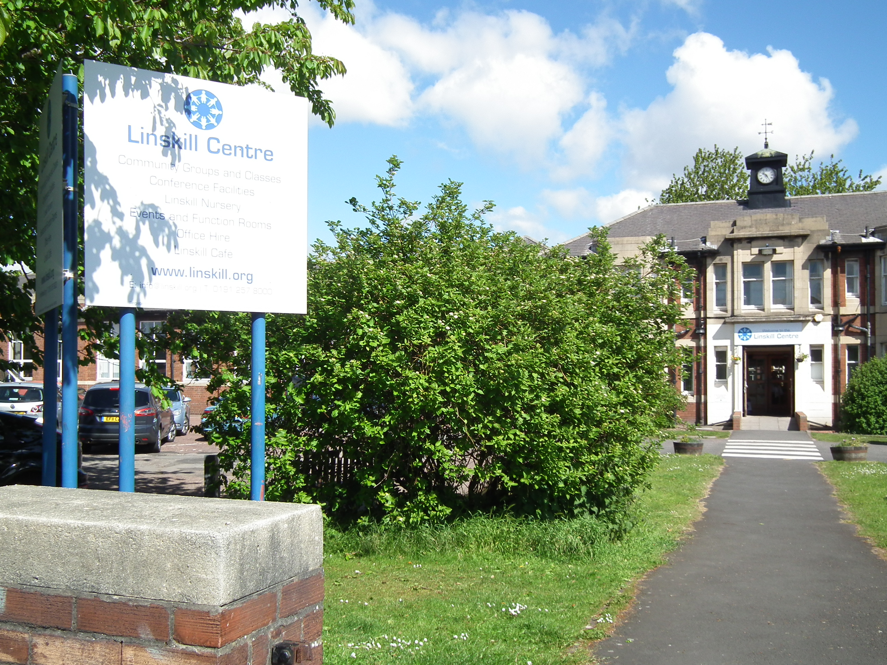
Linskill & North Tyneside Community Development Trust
Key learning point: Be realistic about the prices you charge and how much income your room hire will generate. If this does not cover your running costs, then you need plans to make up the shortfall through fundraising, community enterprises, events, etc. Not all buildings can earn enough through income from room hire and managed workspace to cover their running costs.

As part of work to improve its financial viability, the Trust reviewed its room hire charges. The new charge per hour for some long-standing users was increased. The Trust met face-to-face with each affected group to share the reasons for the increase. Some groups left but overall income from room hire has increased year on year by approximately 15% Linskill Centre continues to be well used by local community groups – hobby and local interest groups attract a 50% discount on room hire rates. Realistic room hire rates contribute to the long-term financial stability of the Trust and allow the trust to both invest in new facilities and ensure it provides good quality services to its users.

Showing your Costs
Expenditure
Utilities | £7,200
Water | £840
Office and Building Supplies | £1,550
Telephone | £930
Repairs and Maintenance | £2,890
Licences and Insurance | £2,580
Cleaning/Caretaking | £10,500
Major Repairs Fund | £3,000
Total | £29,490
As suggested in the case study above, it can be helpful to provide information to customers to show what it costs to run your community building. Particularly if you are having difficult conversations about increasing prices, it can be useful to show how the money paid for room hire is used to keep the building open and to pay for essential items like utilities and cleaning and repairs.

A simple example budget is provided in the table on the right. It shows the type of analysis that might be useful to undertake to inform pricing. The pie chart below breaks down the expenditure into percentages of costs per year.

Management:
You are responsible for managing the building. This includes ensuring health and safety, fire safety, testing and licenses, food safety, child protection (there are checklists in To Have and To Hold). Check what licenses you need to cover activities which go on in your building. Most community buildings need a PRS music licence, which covers the playing of recorded music, and a TV licence. You will need licences if you want to put on performances or serve alcohol. Check if there are any restrictions set out in the freehold or leasehold of your property.

Many community buildings have limited or no staffing so rely on volunteers for a range of tasks like cleaning, booking rooms, repairs and maintenance. Some community buildings let rooms out without having staff or volunteers on the premises. They may do this through remote access, key codes or arranging for the hirer to collect the key from the local shop. Make sure that you explain the management of the building to your insurer and check that your policy is suitable for the way that you run the building.

Having regular hires is a reliable source of income and, even if you might make slightly more with ad hoc hires, it can be easier for volunteers to manage regular bookings. There is less admin, access arrangements are sorted out and users know the building so don’t need an induction.

It is good practice to have a written agreement with your hirer. This clarifies the terms and conditions of the letting and can be referred to if there is any dispute. An example document is provided at Appendix A.

There will be problems so it is helpful to set a clear policy in advance so everyone is clear about how to deal with issues from a regular thirty minute booking blocking an all-day conference booking to conflicts between hirers about noise. Try to anticipate problems. One group advertising their activity with a banner outside the building might seem reasonable but what happens if fifty groups all want a banner?

Understanding costs

Understanding costs begins with your expenditure budget (you can find a basic budget for a community building in To Have and To Hold). Your building will have a mix of lettable space and common areas (like toilets and corridors) which do not generate any income. Most organisations have to work with their current building layout. However if there are options to reshape your building to create more lettable space then this may improve your finances.

Part of understanding your costs is to know the size of your building and the sizes of the spaces within it – those which are lettable and those which are not. The example below shows how to calculate your running cost per square metre of lettable space. You can then compare your annual running costs per square metre of lettable space against the rent or room hire charge.
Worked example:
Table 3: Sizes of rooms for hire

Calculating Sizes
Room | Dimensions | Square Metres
Office | 6 m x 6 m | 36 sq m
Meeting Room | 6 m x 6 m | 36 sq m
Reception | 8 m x 4 m | 32 sq m
Toilets | 4 m x 4 m | 16 sq m
Hall | 30 m x 12 m | 360 sq m

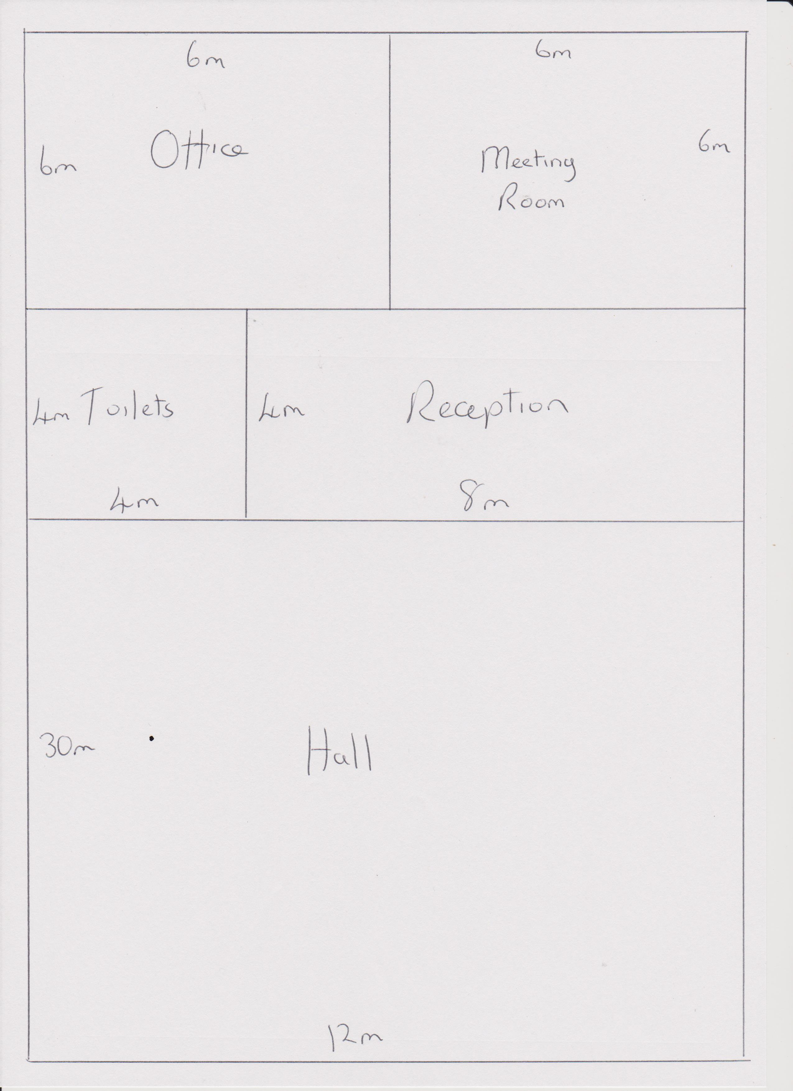
In our simple example the building is open Monday-Friday 50 weeks a year, so 250 days per year. There are only two lettable spaces – the meeting room and the hall, (see illustration to the left).
Total space in building = 480 square metres.
Total lettable space in building = 396 square metres.

Nearly 20% of the building is common areas – reception, toilet and office - which do not earn income.

If running costs are £20,000 per year then cost per square metre of lettable space (£20,000/396) is about £51 per year. The hall must earn £18,360 just to cover its costs (360 sq m x £51 per sq m), If you divide £18,360 by 250 days, this shows that the hall needs to earn £73 every day the building is open just to cover its costs – i.e. 3 hours per day at £25 per hour or 8 hours a day at £10 per hour.

In this example, if the hall is only booked for 3 hours each weekday evening, then a charge of less than £25 per hour means it is not covering its basic running costs.

These calculations can help you to understand how your costs relate to your income. Of course setting rents and room hire charges is more complicated as discussed earlier, but understanding the costs in relation to use of your building helps you to make informed decisions.

Business Rates

One further important area in relation to costs is business rates. The starting point is that, as the organisation occupying the space, you will be liable to pay business rates (and you may be getting mandatory relief if you are a charity). However, if you are sub-letting an area of the building in a way that gives exclusive use to your tenant, then it may be that they will become liable for the business rates for that area only (and if they are not a charity, they may have to pay in full). This is because part of the legal test for paying rates is occupation of the property.

Equally, if you are a charity that is not sub-letting but allowing other organisations to use the space, then you need to be careful if those other organisations are not charities. You need to be able to show that their use of the space helps to meet your own charitable aims, as any mandatory rate relief that you get depends on the property being used for charitable purposes.

Marketing

Some community organisations view their work as providing a service to the community, so do not see the need to market their building. However marketing is just one aspect of maintaining really good links with your local community. Community organisations often use Facebook to keep local people up to date with what is going on. So if self-employed tutors book space to run classes in, say, Zumba or flower arranging this is immediately posted up and they get bookings. The centre is a popular place to run these classes because it is easy to get participants - a virtuous circle. Plus being able to demonstrate excellent links to the local community helps raise grant funding.
Managed Workspace:
Use your market research (as discussed in section 2) to develop your marketing strategy. That will give you information about the tenants you want to attract and how to contact them. Finding new tenants is likely to be a combination of networking and word of mouth, website and social media. If you have a lot of managed workspace, you may employ a lettings agent.
Room Hire:
To attract new customers, you need to market your room hire offer. Start with small actions. There are lots of ways from signs outside the building and posters in local shops to Facebook and Twitter. Consider what you are offering to customers and check out what your marketing materials convey to customers. Do you come across as welcoming, efficient and principled?
Be clear about what customers can and cannot do in the building. Explain any restrictions on alcohol, gambling or operating late in the evening. Can those hiring a room bring in their own catering or can they only buy catering from your organisation? If you hire out IT equipment – display screens, projectors, etc. – be clear about what equipment your hirers need to bring with them and whether or not there is any support to help them operate your equipment.

Make sure your booking system is responsive. Customers who do not know you, particularly businesses and people arranging social events, need a quick if not instant response. If they do not get a prompt response they will go somewhere else.

To attract customers from outside of your local area you will probably need to develop a website. Make sure that the website gives clear information about what is on offer, what it costs and how to book it. Remember to update your website regularly. An out of date website will not help your marketing.
Key learning point: Check out options to do joint marketing with other community buildings in your area. Though there may be an element of competition, most community buildings have a slightly different offer and can work effectively together. A well designed website and shared booking system can increase the number of commercial and private hires – i.e. customers paying higher rates for room hire - and increase bookings from outside your local area. This should increase the financial viability of your community building.

Appendix A) Room Hire Information

The following advice and guidance on room hire, terms and conditions and a booking form is provided as an illustration, and may need to be adapted to suit local requirements.

Information on Rooms for Hire:

- Room hire price list for different categories of user and different times (e.g. daytime, evening, weekends)

- Rooms available for hire and their seating capacity

- When rooms are available (e.g. Monday-Saturday 9 am – 9 pm)

- Equipment hire prices

- Catering options and prices

- Any restrictions – e.g. no alcohol

- Location of building including a map

- Travel instructions

- Gaining access to the building – e.g. “It is the responsibility of the hirer to arrange to pick up a key for the building or to meet a representative of our organisation at the building on the day of hire. Please make arrangements in advance to collect and return the key.” Including description of any potential issues for those with mobility difficulties

Appendix B) Terms and Conditions

Terms and Conditions of Room Hire:

These are examples of what you might include in your Terms and Conditions of room hire, you will need to adapt as appropriate.

- Room hire is only secured upon receipt of a completed booking form, receipt of a deposit for 50% of the room hire charge and our confirmation of the booking. The deposit is non-refundable in the event of cancellation by the customer.

- In the event of a cancellation by the customer for any reason the following charges will apply:
- One week or less before the date of hire commencement– 100% of the room hire charge.
- More than one week before the date of hire commencement – 50% of the room hire charge.

- Payment for the remainder of the room hire fee and any fees due in respect of catering or equipment hire will be due within 30 days of receipt of the invoice raised for these items. In the event of late payment, any reduced rate will not apply and the rate for a commercial customer will be charged. OR
- The balance of the room hire charge must be paid in advance of the booking date.

- We reserve the right to cancel bookings and will aim to give reasonable notice except in cases where the cause of cancellation is beyond our reasonable control or if a customer is in arrears from a previous booking.

- We reserve the right to alter or amend prices or other details shown on the website or other literature. Customers will be invoiced for the rates applicable at the time their booking is confirmed and it is the customer’s responsibility to check the rates applied.

- Our fire evacuation plan, health and safety, food hygiene and child and vulnerable adult protection policies are posted on the notice board at the entrance to the building and on our website. It is a condition of booking that hirers familiarise themselves with this information.

- The customer is responsible for their own equipment brought onto the premises, and for any damage caused to our property or fixtures by persons or equipment brought onto the premises by the customer.

- We will not accept liability for:

- the death of or injury to the customer, its employees or delegates; or
- loss or damage to any property belonging to the customer, its employees or its delegates;
- any losses, claims, demands, actions, proceedings, damages, costs or expenses or other liability incurred by the customer or its employees or delegates in the exercise of the rights granted by the booking.

Nothing in these terms and conditions shall limit or exclude our liability for:
- death or personal injury or damage to property caused by negligence on the part of us or our employees or agents; or
- any matter in respect of which it would be unlawful for us to exclude or restrict liability.

- The customer acknowledges that:
- no relationship of landlord and tenant is created between us and the customer by this hiring agreement;
- we retain control, possession and management of the Building and the customer has no right to exclude us from the Building;
- the hiring agreement is personal to the customer and cannot be assigned.

- The customer shall be liable and indemnify us against any claims, demands, actions, proceedings, damages and costs or other liability in any way arising from this agreement that are brought against us of whatever nature including, but not restricted to, claims in respect of death, injury, loss or damage where any such claim arises by the actions, omissions or neglects by the customer.

- The customer must have their own public liability insurance and provide a copy to us at least 10 working days before the hire commencement. If they do not, they must inform us and their booking may be refused.

- In the unlikely event that we have to cancel a booking, a full refund will be made (unless the cancellation was due to the customer being in arrears).

- Rooms will be set up according to the instructions received on the booking form. We cannot be responsible for any last minute changes of layout or equipment required.

- Any extra assistance additional to initial equipment set-up may incur an extra charge OR
- Please note that we do not provide IT support. Customers may make an appointment in advance of their booking to ensure that they can operate our equipment.

- Our organisation provides catering services so customers may not bring in their own food and drink without prior arrangement. We reserve the right to make a charge for this. Nuts and other allergens may be present in the kitchen OR
- Customers may bring their own food and drink onto the premises provided that we have given prior consent. Hirers may use the kitchen facilities and must abide by the manuals and safety guidance on display in the kitchen.

- Alcohol is not permitted in the building OR
- If you wish to serve or sell alcohol, you must obtain our agreement at the time of booking. You will be required to complete and sign a separate form setting out your requirements and agreeing to abide by conditions on the sale and serving of alcohol.

- Gambling is not permitted in our building OR
- Activities such as bingo, raffles and tombolas are permitted within the building. If your booking involves any other type of gambling, you must obtain our prior permission. We reserve the right to refuse permission.

- You must have our prior permission if your booking is for public performance, dancing or showing motion pictures. Please provide as much detail as possible on the booking form. You will be required to procure any necessary licences for your event (for example copyright licences to play music) and must provide us with copies at least 10 working days before the hire commencement date.

- We operate a non-smoking building and smoking regulations must be observed by the customer at all times. Details of the designated smoking points can be found in reception of the Building.

- The customer and its delegates are expected to behave in a responsible manner and with due regard to our regulations (including those relating to statutory fire and safety requirements) and any reasonable instructions given by employees or volunteers from our organisation.

- We provide a First Aid box in the kitchen which is available to all users. Please report any accident or injury to the [Bookings Secretary]. OR
- We do not provide a First Aid Box so the hirer is required to make their own provision. Please report any accident or injury to the [Bookings Secretary].

- [If you have planning or licencing restrictions on late opening.] Our confirmation will include the start and finish times for your room booking. For evening events, please note that the event must finish by 11.30 pm and the premises must be cleared by midnight. Please respect our neighbours and leave the premises quietly.

- Hirers are expected to return furniture and equipment to their original position and to leave the space clean, tidy and clear of rubbish.

- Hirers are not permitted to display any signs, advertisements, banners, posters or similar item outside the Building without our prior consent.

- No conduct may be carried out that may invalidate our insurance policies. A copy of our insurance policy can be found on the notice board in reception.

- Hirers are required to be on the premises at all times during the hire period. We may not have staff or volunteers on the premises during the hire. Hirers are required to ensure that the premises are secure during their hire period and that they leave the premises safe and secure. Further details on this will be included in the confirmation letter and on our website.

- Any breach of these terms and conditions may result in the termination of a booking.

- Blue tac / white tac / sticky tape of any description is not to be used on the walls.

Appendix C) Example of a Booking form
Title First Name* Surname*
Choose an item.

Address

Phone* Email*

Type of organisation
Choose an item.

Event details including date, times, type of event, number of attendees

Details of room required and set up

Equipment required (list your equipment available, below is a suggested list)
Choose an item.

Catering requirements including timings and dietary requirements

Access requirements, hearing loop, wheelchair access etc.

☐ Agreement to terms and conditions of booking*

Signature Date of booking Click here to enter a date.

Address to send completed booking form – this may be an email address – plus other contact details.

Note: you may want to include notes at the end of your booking form that states: The booking will not be accepted until confirmation is provided.

You may also wish to provide estimate of when hirer should expect to receive confirmation, e.g. if you have not heard from us within three days of submitting your booking form, please call us on ….

©2016 Community Ownership and Management of Assets
Visit the My Community
website to find out more:
http://mycommunity.org.uk/
Follow us on twitter: @mycommunityhelp

